Another Case for Training Harder
and Resting Longer in Strength Training
Tom Kelso, M.S., M.S.C.C.-E, C.S.C.S.
Exercise Physiologist, St. Louis Metropolitan Police Department

“It is not stress that kills us, it is our reaction to it”
Hans Selye The Stress of Life
Bottom line: Train harder but train less frequently. Amen.
If more people world-wide heeded that there would be more muscle mass, more muscle strength, and less body fat on the planet.
You can stop reading now if you’d like because that is the gist it. However, if you want more details sally forth.
Key Points:
- Homeostasis:
An organism’s process of maintaining a stable internal environment suitable for
sustaining life. https://biologydictionary.net/homeostasis/

The state of steady internal, physical, and chemical conditions maintained
by living organisms.
https://www.amazon.com/Anatomy-Physiology-J-Gordon-Betts- ebook/dp/B075FFXDX4

- Any stress applied compromises homeostasis and the body must deal with it, either negatively or positively.

- Types of stress include environmental (i.e., heat, cold), emotional (i.e., anxiety), physiological (i.e., muscle fatigue, dehydration), or social (i.e., relationship issues) among others.

- The human body requires proper nutritional intake, sleep, and down time each day to achieve an optimal homeostatic state independent of the quantity and magnitude of other stresses incurred. In plain English: even the average person who is mostly inactive throughout the day (mostly sitting, no exercise) requires adequate rest and food intake to survive and advance their entire lifetime.

- Aside from other stresses incurred on a daily basis, physiological stress – in this case the physical exercise classified as strength training - by itself can overwhelm one’s homeostasis and exacerbate the recovery process.
- The physiological stress of proper strength training must be strong enough to elicit adaptation. If not strong enough the body will have no reason to adapt.

- Those who engage in physical demanding strength training (or other forms of exercise) - in addition to incurring other types of daily stress - need to pay greater attention to the timing/dosage of training sessions in addition to the importance of the sleep and nutrition factors to maximize the recovery process
Regarding the last bullet point it is important to understand one undeniable fact: proper exercise must be physically challenging relative to one’s current status. The physical effort exuded must be demanding and intense, whether one is a beginner or seasoned veteran. What does that mean? Simply give 100% effort, whatever your 100% is at the moment. You’re attempting to make changes in your body and the only way to accomplish that is by pushing yourself beyond what you are currently capable of. Yes, it’s going to be temporarily uncomfortable, but you need to have a starting point to know what ability you currently possess. You can only measure progress by giving it all in the moment, documenting it, then attempting to do more in the following session. I know that is oversimplified, but it is essentially how it is done: 1) train hard to create the stimulus to disrupt homeostasis (stress) 2) recover to allow improvement (proper downtime, sleep, and nutrition) 3) realize that improvement (adaptation) 4) attempt to do more in the forthcoming sessions (progression). That rudimentary formula is the underpinning of any successful exercise program.
If one is beginning a training program, naturally they are “untapped” and starting on square one, but they must give 100% effort to determine “where they are.” If one has been training for a long time – thus has “tapped’ into their genetic potential and has made good progress – they too must give 100% effort to continue challenging their muscles to make further progression. Always remember even those who have made outstanding gains in the physical capacity of their muscles (and the same for aerobic ability and short-term anaerobic endurance) also experience fatigue from a proper training session because they must push themselves beyond their current status if they desire to maximize their potential.
So, regardless of the type of one’s physical goal(s) – muscle strength, muscle size, aerobic capacity, running speed, short-term endurance, power output, agility, etc. – hard effort to push beyond one’s current status is always the first requirement for sound training.
TRAIN HARDER AND TRAIN LESS FREQUENTLY
SPECIFICALLY FOR STRENGTH TRAINING, it’s time to get the bottom line on why it’s best to train harder and less frequently. Always remember that doing something is 100% better than doing nothing, but it is also important that whatever is done needs to be as accurate as possible in terms of the proper stimulus/dose and the timing of each subsequent stimulus/dose. Like prescription medication, a specific amount is required on a specific schedule to realize the benefits of its application. Too much or too little on a random schedule can be either ineffective at the least or harmful at most. On that…
Here are some typical program formats currently used in the strength training world:

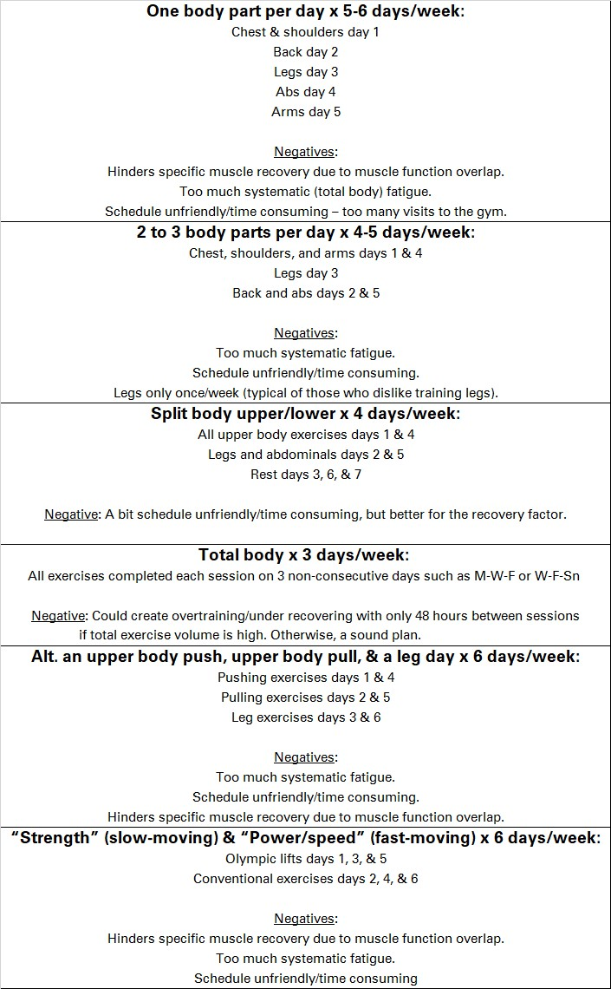

Note the common negatives of some of the formats above:
- Inadequate recovery for specific muscle groups between training days. Working similar muscles on adjacent days before they have been allowed to fully recover is not recommended. Applying a coat of paint? You better let it dry before applying a second, and that may take a while.

- Systematic recovery issues. Along with the first point, even though separate body parts are trained on different days, the entire body is affected (and requires recovery) due to the complex network of all body systems (endocrine, nervous, circulatory, lymphatic, immune, etc.) Remember, one’s body needs proper nutrition, sleep, and down time to properly heal and function each day independent of extreme physical stress, so when too much/too often physical stress is added to the menu it can hinder progression.

- The age-old maxim of “more is better” is not prudent for physically demanding exercise, because if it was true, one should train every day, allot four to five hours for each session, perform dozens of exercises, and complete hundreds of repetitions. That would be completely insane. Always remember the proper dose/timing factor. It’s usually a lot less than many believe.

- Scheduling will always be an issue, and it’s usually the roadblock that prevents one from training regularly and achieving their goals. Many still believe in the more is better maxim and schedule too many training days, spend too much time in the gym, burn out over time, then totally abandon their training. A normal 16-hour day is chock full of commitments: work, personal time, meal consumption, travel time, family matters, etc. Not many have multiple days of 2+ hours to set aside for going to the gym. Those that do are mostly the type who need to satisfy a social/bonding need with their homies at Pump Central, Inc. And from personal observation many of that ilk do not truly train hard. They socialize too much, play with their hand-held computer (a.k.a. cell phone) every few minutes, perform multiple sets with sub-maximum effort, spend too much time resting between sets, avoid working their important lower body muscle groups (because doing legs properly is HARD), thus spend more time doing nothing, and less time actually training. So, let’s be clear on this:
YOU DO NOT NEED TO STRENGTH TRAIN 4+ DAYS/WEEK AND 2+ HOURS/SESSION TO GET GOOD RESULTS. There are plenty of testimonials of great results from training only two to three times per week and less than 45:00 each session. That is schedule-friendly and allows plenty of time to complete quality stimulating sets if one works hard, stays focused, and minimizes the down time between sets.
Peer-reviewed research exists that proves one does not need to train frequently if they train hard. In fact, there is solid proof that infrequent training is best for optimal recovery. It’s based on that concept of physiological stress that mandates adequate recovery time to realize positive adaptation:
http://1rm.es/wp-content/uploads/2018/02/Mora%CC%81n-Navarro-et-al.-2017.pdf

“Resistance training leading to failure considerably increases the time needed for the recovery of neuromuscular function and metabolic and hormonal homeostasis.”
Stability of a practical measure of recovery from resistance training:
“Results of this study, in contrast to some recent studies, suggest that 48 [two days]
hours of recovery between resistance training sessions may be adequate for some people.”

“…the general recovery duration of the majority of the participants…reported that most participants (80%) returned to baseline by 72 hours [three days].”

Time Course of Strength and Power Recovery After Resistance...: The Journal of Strength & Conditioning Research (lww.com)
“The slow velocity (SV) and fast velocity (FV) presented significant leg press (LP) 1-RM decrements at 0, and these were still evident 24-48 hours postexercise. The magnitude of decline was significantly higher for FV. The SV and FV presented significant horizontal countermovement jump decrements at 0, but only for FV were these still evident 24-72 hours postexercise. The SV and FV presented significant thigh circumference increments at 0, and these were still evident 24-48 hours postexercise for SV but for FV it continued up to 96 hours.”

Recovery from training: a brief review: brief review:
“Maximal voluntary contraction (MVC) ability was not fully recovered (restored to baseline levels) at 132 hours [five and one half days] after exercise.”

“In one group, MVC was not recovered for at least 33 days, and in one subject, MVC had not recovered when last tested after 89 days of recovery.”
“…Subjects performed 3 sets of 10 repetitions of 8 exercises, all to momentary muscular failure. Then in counterbalanced order, we had them try to replicate the same workout after 24, 48, 72, or 96 hours [four days] of recovery…None of these participants was able to reproduce their 10-RM at 24 hours. This suggests that they were not fully recovered. After 48 hours of recovery, 40% of our subjects were recovered. After 72 hours of recovery, and after 96 hours of recovery, 80% were recovered. When the sets were increased to 7 sets of each to failure, recovery was delayed as would be expected.”
“When older (50 to 65 years of age) trained men repeated the 3-set protocol, recovery was delayed, compared to younger exercisers. For example, in 70% of the cases, participants were unable to replicate their baseline performance even after 96 hours, suggesting recovery was not complete.”
“…examined training recovery reliability. In that study, 10 college-aged resistance trained males performed 3 sets to volitional failure using a 10RM load for 6 exercises. Recovery was evaluated by the number of repetitions performed following recovery periods of 48, 72, 96, and 120 hours [five days]…When all 6 exercises were pooled, 80% of participants returned to baseline strength levels after the same recovery duration. However, individual muscle group reliability varied from 20% to 70%...When considering summed repetitions for 6 exercises it took 72 hours for 80% of the participants to return to baseline, but in this study we found that by 48 hours 70% of participants had returned to baseline performance…It appears that acute recovery also varies within a given person from one training session to another.”

High‐intensity resistance training with insufficient recovery time between bouts induce atrophy and alterations in myosin heavy chain content in rat skeletal muscle
“These data show that high-intensity resistance training with insufficient recovery time between bouts promoted muscle atrophy and a transition from slow-to-fast contractile activity in rat plantaris muscle.”

THE WRAP: Your body (muscle size and strength) wants to remain as it currently is, so to make any changes it must be exposed to a very significant stress (hard training) to make it change. If one trains hard to create a much-needed stimulus for future adaptation, it will result in the need for time (rest and sleep) and fuel (proper nutrients) to grow/repair/improve. That may take three or more days for it to occur. Why, then, do people go to the gym day after day before they are completely recovered only to disrupt that beautiful stimulus for adaptation which they created in the prior training session? It’s either the “more must be better” work ethic (which does apply to other things in life), or the panic of “I’ve got to do some type of training every day or I feel like I am cheating myself” mentality that creeps into their brain.
Reward yourself for working hard by making the down time away from grueling exercise the prize. Then let biology run its course. You will also have more time for other important commitments in your day. And no, you will not immediately regress/plummet to your previous level when you schedule that extra day or two of recovery. In fact, you’ll allow for the complete adaptation to occur, be well-rested prior to the next training session, then possess more enthusiasm to get after it again (that 1st coat of paint is now completely dry so let’s go!).
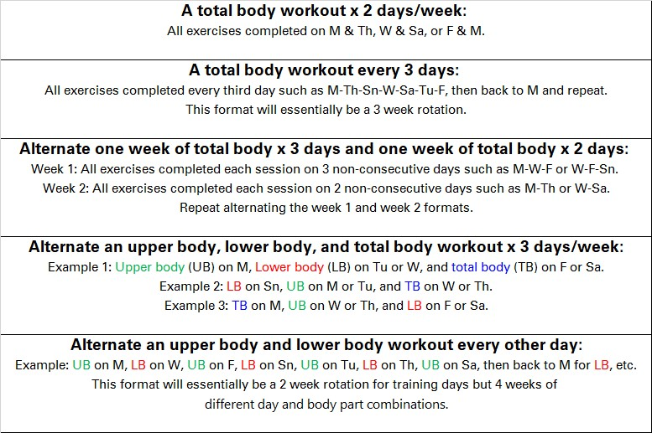
Try these effective training formats. They allow for hard, stimulating work followed by plenty of recovery time between sessions. You’ll definitely see results provided you follow the format consistently, go all-out each session, and adhere to proper nutritional intake relative to your goal(s):

